Behaviour Policy

Contents
- Introduction
- Calm, Consistent and Kind Adult Behaviour
- First attention to best conduct
- Restorative and inclusive approaches
- Child on child abuse
- Children with SEMH needs
- Bullying
- Exclusions

Appendices:

- School Behaviour Blueprint
- Restorative Process
- Behaviour toolkit
- When things kick off checklist
- Recognition board
- Class Dojo
- School Certificates
- Calming Strategies

Introduction
Introduction
Diocese of Bristol is committed to creating an environment where exemplary behaviour is at the heart of productive learning. Everyone is expected to maintain the highest standards of personal conduct, to accept responsibility for their behaviour and encourage others to do the same. Our behaviour policy guides staff to teach self-discipline not blind compliance. It echoes our core values with a heavy emphasis on respectful behaviour, a partnership approach to managing poor conduct and dynamic interventions that support staff and learners.

Aims of the policy
- To promote a positive, calm and safe environment where all children can flourish.
- To establish a framework for staff that focuses on consistencies, high expectations and positive relationships.
- To create a culture of exceptionally good behaviour; for learning, for community, for life.
- To ensure that all learners are treated fairly and shown respect.
- To help learners take control over their behaviour and be responsible for the consequences of it.
- To build a community that values kindness, care, good humour, good temper and empathy for others.

Our Behaviour Policy is based on the Five Pillars of Pivotal practice
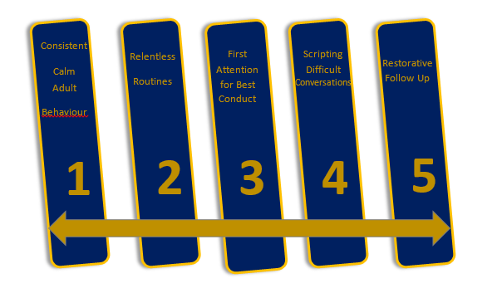

- Calm, Consistent and Kind Adult Behaviour
At xxxx C of E Academy, we believe that Calm, Consistent and Kind adult behaviour is the foundation for good behaviour management.

Calm, consistent adult behaviour means being in control of yourself before you attempt to take control of anyone else’s behaviour. Calm, consistent adult behaviour means that there are no gaps between the adults and there is an agreed plan we stick to (Pivotal, 2017).

At xxxx C of E Academy, we are a staff team and work together. We have a tight, firm foundation. We do not shout, we do not aggress, we do not show negative emotion when intervening with behaviour.

We do this by using scripts and relentless routines to deal with challenging behaviour

Routines are the cogs at the centre of all classroom practice. At xxx C of E Academy, we recognise that where Calm and Consistent Routines are established, children feel secure to take risks in their learning.

A firm foundation means that we use the same rules and language in every classroom.

Rules

At our school we recognise the importance of providing clear rules underpinned by our values and vision. The rules of Ready, Respectful and Safe are understood by all children and adults in school. Our values of Caring, Sharing, Respecting, Forgiving and Questioning underpin the rules.

Routines are the cogs at the centre of all classroom practise. At xxxx C of E Academy, we recognise that where ‘Calm, Consistent and Kind’ Routines are established, children feel secure to take risks in their learning. Successful routines have a maximum of 3 simple steps.

Expectations of ALL Adults

We expect every adult to:
- Meet and greet at the door
- Refer to the school rules
- Model positive behaviours and build relationships.
- Plan lessons that engage, challenge and meet the needs of all learners.
- Use a visible recognition mechanism throughout every lesson (e.g. Recognition boards)
- Be calm when going through the steps.
- Restore the relationship with the learner, retain ownership and engage in reflective dialogue with learners.

Please see Appendix A for our school’s behaviour blueprint.

- First Attention to Best Conduct
At xxxx C of E Academy, we catch children doing the right thing first. We focus on the 95% children doing the right thing all the time first, because those are the children that deserve our first attention. This does not mean that we are ignoring poor behaviour, but the first focus of all adults should be recognising doing the right thing first (Pivotal, 2017).
We do this by using the following:
- Verbal praise
- Class recognition board
- Class Dojo for specific praise

- Restorative and Inclusive Approaches
At, xxxx C of E Academy we know the value of showing a child their behaviour and teaching them new behaviours. We know that punitive punishment has its limitations and doesn’t teach new behaviours. Individual staff dealing with their student’s own behaviour has enormous value. This is both in terms of the child’s immediate behaviour and the long term relationship between the adult and the child.
We have put the following in place to support the children:
- Emotion Coaching and Restorative Processes
- Use of ‘The Nest’ as a calm space in the school building
- Plenty of use of outdoor learning areas
- Time to Talk counsellor (where needed)
Children with Social, Emotional, and Mental Health Needs (SEMH)

Behaviour can be a means of communication that can indicate current/ recent trauma or adverse childhood experiences (ACES) or other mental health needs. We must ensure that all pupils are supported to communicate their needs safely and appropriately. We recognise that some behaviour may be a direct result of a child’s vulnerability and can be closely linked with safeguarding and therefore not solely linked to SEMH.

xxxx C of E Academy provides the following in-school support for children with SEMH:

Add school specific examples e.g.

- Safe areas for children
- Pastoral Support Team and Program
- Angry and Anxiety Gremlin Cognitive Behaviour Therapy
- Trauma informed school
- School mental health support worker

Staff ensure that children are supported in a way that matches their age and needs whilst establishing and maintaining the highest expectations for all children. Individual Behaviour and Safety Support Plans are created when appropriate and designed to meet the specific needs of the child. A trauma-informed approach is used throughout the school. Where needed, we gain expert advice from Add school specific examples e.g. our area's Primary Mental Health Specialist, Bristol Inclusion Team, Not Just Behaviour Support, Educational Psychologist, and the area’s Mental Health Support Worker.

If a child becomes so dysregulated that it seriously affects their mental health, they may be asked to go home to calm down in order to support their mental health. If this is the case, a full investigation will take place to determine the cause of such a deterioration in mental health. A programme of support will be put in place to support that child back to education and prevent this from happening again.

Child-on-Child Abuse and Bullying

Child-on-Child abuse is behaviour by an individual or group, intending to physically, sexually, or emotionally hurt others.

All staff recognise that children are capable of abusing their peers including bullying (including online bullying) physical abuse, sexual abuse and sexual harassment, initiation/hazing type violence, and rituals.

Bullying is the repetitive, intentional hurting of one person or group by another person or group, where the relationship involves an imbalance of power. It can happen face-to-face or online (Anti-bullying alliance, 2021)

The following measures are in place to prevent bullying:
Add school specific measures e.g.

- Anti-Bullying week and have a program of PHSE lessons to follow up after the Anti-Bullying week.
- During internet safety week, we cover online bullying.

Where bullying has occurred, we support both the victim and the perpetrator(s) with follow-up bespoke social, emotional, and mental health support.

Child-on-Child including sexual abuse and harassment, are dealt with very seriously. We follow the school’s safeguarding protocols (please see the safeguarding policy). We recognise that for children, the perpetrator may also be at risk and this behaviour could be because that child could also be in danger. Where sexual harassment peer-on-peer abuse occurs, we always seek advice from add school specific information e.g. Brooks Traffic Light tool, our Police Constable Support Officer and First Response.

xxxx C of E Academy, we ensure that any form of abuse or harmful behaviour is dealt with immediately and consistently to reduce the extent of harm to the young person, with full consideration to the impact on that individual child’s emotional and mental health and well-being.

All child-on-child abuse including bullying, dysregulated behaviour and intolerant (sexist, racist, intolerance towards religions, homophobic, transphobic, and disablist) incidents are added to CPOMS and investigated thoroughly. They are regularly analysed and reported to the Academy Council three times a year. Please see the school’s safeguarding policy for more information.

Child-on-child abuse is behaviour by an individual or group, intending to physically, sexually, or emotionally hurt others. All staff recognise that children are capable of abusing their peers including bullying (including online bullying) physical abuse, sexual abuse and sexual harassment, initiation/hazing type violence, and rituals.

At xxxx C of E Academy, we ensure that any form of abuse or harmful behaviour is dealt with immediately and consistently to reduce the extent of harm to the young person, with full consideration to the impact on that individual child’s emotional and mental health and well-being.

All child-on-child abuse, bullying, behaviour, dysregulated and intolerant (sexist, racist, intolerance towards religions, homophobic, transphobic, and disablist) incidents are add school specific information e.g. added to CPOMS and investigated thoroughly. They are regularly analysed and reported to the Academy Council three times a year. Please see the school’s safeguarding policy for more information.

Exclusions

Fixed Term Exclusions (External)

We believe that, in general, exclusions are not an effective means to help a child move their behaviour on. However, if the children have been very unsafe and the other children are at risk of harm. An external exclusion will be used to reset the class and the child. A plan for reintegration will be put in place. The meeting will review what is already in place and what else can be done to support the pupil in achieving a successful reintegration. Each day is a new day and where a child has transgressed it is expected that they will be welcomed and treated without any animosity when they return. All fixed term exclusions are recorded on SIMS and reported to the Academy Council three times a year. Please see the exclusions policy for more information.

Appendix A – xxxx C of E Academy (Behaviour Blueprint)

This is how we do it here…

At xxxx C of E Academy, we have high expectations of learning, behaviour and respect for each other underpin everything we do. Our staff strive to create independent, articulate thinkers and learners who have the confidence to achieve their ambitions. This drives us in our pursuit for excellence every day.

Rules  Ready  Respectful  Safe | Over and Above  Praise  Recognition Board  Dojo | Visible Adult Consistencies  Meet and Greet  First attention to best conduct  Calm and caring

Calm and Consistent Routines

Emotion Coaching  Step 1 – Notice the emotions  Step 2 – Deal with the behaviour: “it’s ok to feel.... but it’s never ok to....  Step 3 - Problem solve | Sanctions/Restorative process  - Reminder  - Caution  - Last Chance  - Loss of Privilege  - Referral to Headteacher | Restorative Conversation  What happened?  What were you thinking at the time?  How did this make people feel?  What has been affected?  What should we do to put things right?  How can we do things differently in the future?

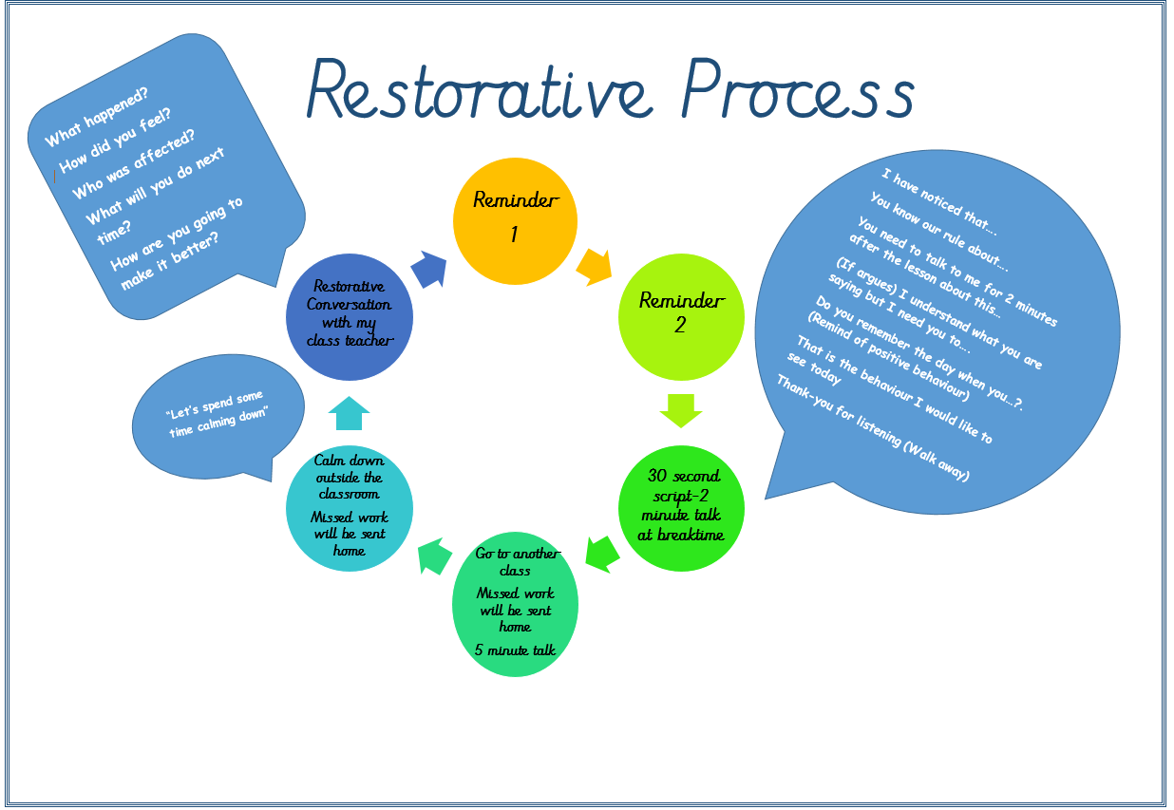
Appendix B - Example
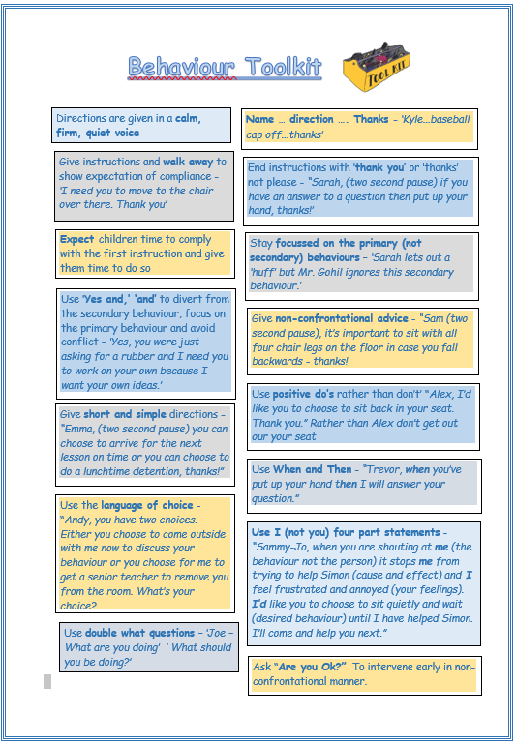
Appendix C -Example

Appendix D – Example
When it Really Kicks Off!
What do you do when a learner really explodes?
Paul Dix (2014) explains what to do and what not to do!
Discuss choices
Clearly and calmly explain the behaviours which you observed, how they relate to the classroom plan and that the student has made a ‘poor choices’ so far. Tell the student that you want them to make better choices. You are then focusing on the behaviours and the student is less likely to feel personally attacked.
Don’t chase secondary behaviours
Focus on the behaviour you are correcting and do not discuss anything else. If the student tries to divert you tell them that you understand what they are saying but they still have a consequence/need to make better choices in their behaviour.
Plan your interaction
Make sure that you take a moment to structure what you are going to say and keep to that ‘script’. Think carefully about your verbal and non-verbal communication. Enjoy the skill of being able to stay in control of the confrontation.
Don’t bring up past misdemeanours
Focus on the single, identifiable behaviour which you have seen. All students start each class with a clean sheet.
Remember that you are the adult
Losing your temper will leave you exposed. Try and see the interaction for what it is – an adult helping a child to learn about behaviour and make better choices.
Get on their level physically
If they are seated, try kneeling or bending over, rather than standing over them.
Avoid negative comments on cultural styles
Students should be allowed to dress themselves and their hair within the agreed limits of the school’s dress code and to move as they please if this does not encroach on the space of others.
Respect students’ personal space
Students may feel threatened and become agitated if their personal space is constantly violated. This does not mean, however, that teachers should ignore bad behaviour.
Use friendly gestures, not aggressive ones
Avoid pointing the finger. Open hands with upturned palms are less threatening.
Use student’s preferred name
Ask each student how he/she would like to be addressed in the classroom and then respect that preference.
Ask questions rather than make accusations
Assume that the student is a responsible person. “Are you ready to begin?” is less confrontational than: “Put your magazine away. It’s time to start class”, especially spoken in a concerned and kind tone.
Deal with the behaviour problem in private
Reprimanding or ‘shaming’ students in front of their peers causes unnecessary embarrassment. Speaking to them privately respects their dignity and self-esteem.
Listen carefully when students speak
Remain open-minded and objective. Consider the messages of students carefully. Avoid interrupting them or offering unsolicited advice or criticism.

Appendix E
Recognition boards
(From ‘When the Adults Change, the Children Change’ by Paul Dix)
A recognition board is the simplest way to shift the culture of your classroom

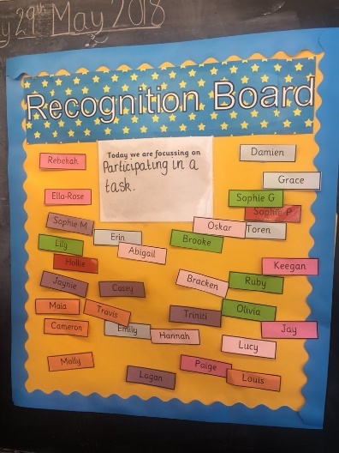
It doesn’t mean it prevents you from dealing robustly with poor behaviour; it just means that you that you are dealing with less of it. The behaviour of one child is not everyone else’s business. It is between you and the individual. The advertising of poor behaviour does not help, but routinely advertising the behaviour you do want does.

Simply write at the top of the board the behaviour on which you want to try and focus on. Try “One voice” for classes constantly talking over each other. Or “speak politely” to emphasise manners or “hands and feet to yourself” for those who give them to others too freely. Perhaps your focus is less about social behaviours and more about learning behaviours. It could be “accurate peer feedback” or “persuasive language” or “show working.”
When you see the children demonstrating the behaviour well, write their name on the board.
The recognition board it not intended to shower praise on the individual. It is a collaborative strategy. We are one team, focused on one learning behaviour and moving in one direction. Pursue the behaviour you want by chasing it hard and reinforcing it enthusiastically. The recognition board fosters a positive interdependence in the classroom, but there is no prize, no material reward. At the end of the lesson/day depending on the context, the aim is for everyone to have their name on the board.
Even pupils who have received private sanctions can be caught demonstrating positive behaviours. One doesn’t cancel out the other. It is perfectly natural to behaviour badly and have to deal with the consequences, and the next minute to do something brilliant and receive the positive consequences. If I drive my car too fast and get caught for speeding, I get a fine and points on my licence. I have done something wrong and I am punished for it. Half a mile down the road I stop to let a group of children and their teacher cross the road. The teacher smiles at me and I have received a positive consequence. Does the policeman run down the road after me having seen my good behaviour offering to tear the ticket up? No of course not. We live with the fact that there are two separate incidents that have distinct outcomes. Yet in many classrooms (and in many homes) the wires are have become crossed and behaviour becomes too complicated to manage well. Behaviour ends up being a game and not a responsibility.
Untangle the behaviour in your classroom by keeping the positive and negative consequences separate.

Appendix E (if you use Class Dojo)
DOJO Guidelines
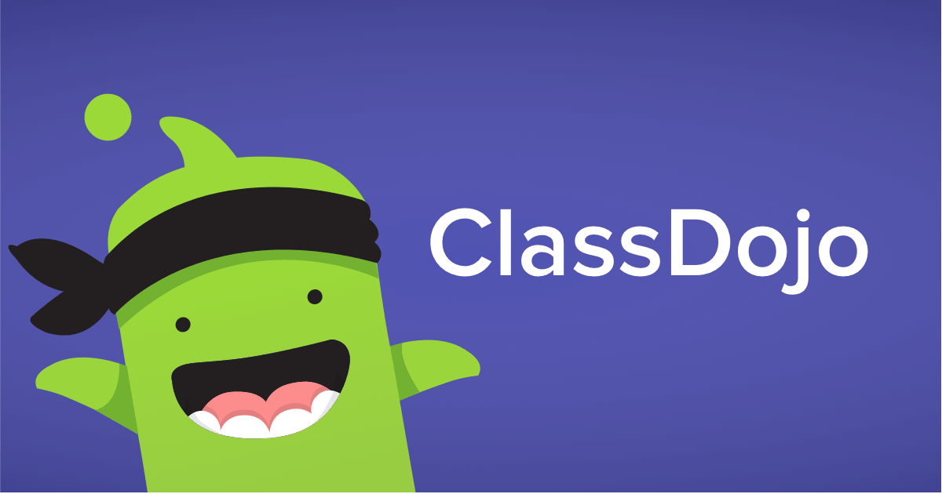

- Use Dojo for Precise Praise
- All parents need to use it – it is the class teacher’s responsibility to ensure this happens
- Never send or reply to a personal message to/from a child
- Update class page once a week
- Refresh Each Child’s page regularly
- Communicate with each child’s parents TWICE a term
- DOJO Star of the day

Appendix F
Add example praise postcards/certificates etc

Appendix F
Add examples of whole school calming strategies

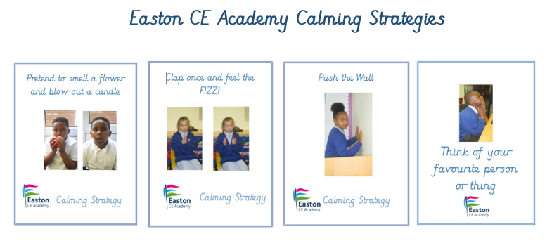

History of most recent Policy changes
Date | Page | Change | Origin of Change e.g. TU request, change in legislation
September 2021 | All | New Policy | Following new KCSIE 2021 and new Pivotal approach adopted across the Trust in consultation with DBAT Behaviour Network
September 2022 | Pages 2 and 6 | Language change | Following new KCSIE 2022 – change in language from peer on peer to child on child
July 2023 |  | No changes

Policy Owner |  | Education Directorate
Date Adopted |  | September 2022
Review Date |  | September 2025
Level |  | Level 2
DBAT Policy levels:
LEVEL 1 | DBAT policy for adoption (no changes can be made by the Academy Council; the Academy Council must adopt the policy)
LEVEL 2 | DBAT policy for adoption and local approval, with areas for the Academy to update regarding local practice (the main body of the policy cannot be changed)
LEVEL 3 | DBAT model policy that the Academy can adopt if it wishes
LEVEL 4 | Local policy to be approved by the Academy Council

